**CONFERENCE MANAGEMENTSYSTEM**

**Use case diagram:**

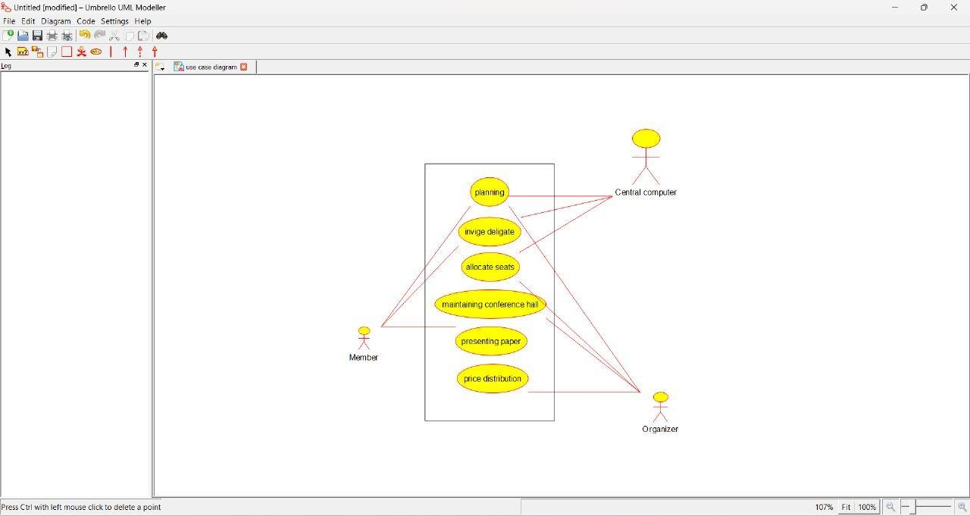

**Class diagram:**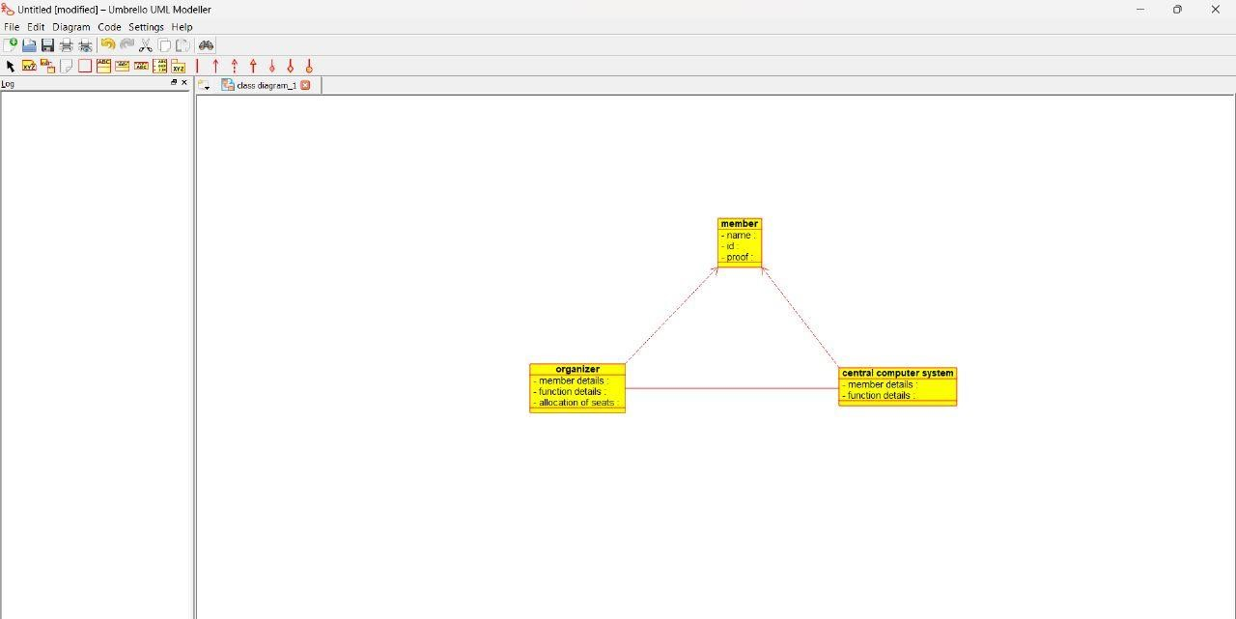

**ACTIVITY DIAGRAM:**

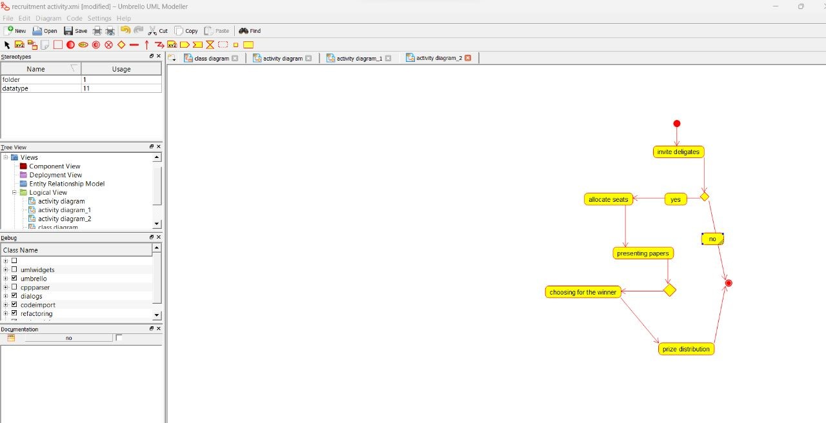

**SEQUENCE DIAGRAM:**

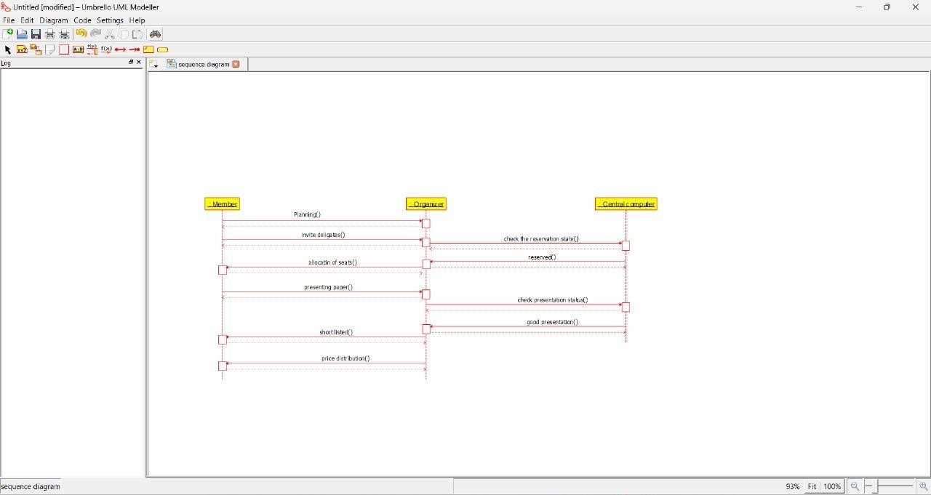

**DEPLOYMENT DIAGRAM:**

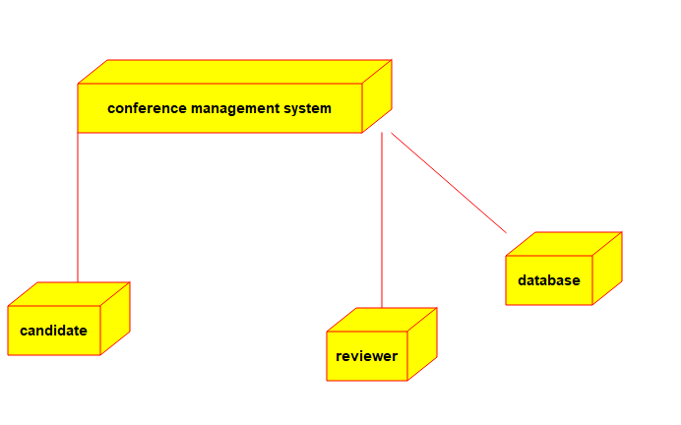

**COLLABIRATION DIAGRAM:**

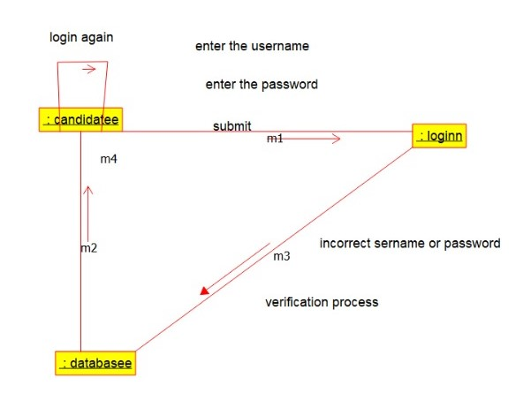

**Program:**

/**

* Class central_management_system

*/

public class central_management_system {

//

// Fields

//

private char member_details;

private char function_details;

private void details_of_seat_allocation;

//

// Constructors

//

public central_management_system () { };

//

// Methods

//

//

// Accessor methods

//

/**

* Set the value of member_details

* @param newVar the new value of member_details

*/

public void setMember_details (char newVar) {

member_details = newVar;

}

/**

* Get the value of member_details

* @return the value of member_details

*/

public char getMember_details () {

return member_details;

}

/**

* Set the value of function_details

* @param newVar the new value of function_details

*/

public void setFunction_details (char newVar) {

function_details = newVar;

}

/**

* Get the value of function_details

* @return the value of function_details

*/

public char getFunction_details () {

return function_details;

}

/**

* Set the value of details_of_seat_allocation

* @param newVar the new value of details_of_seat_allocation

*/

public void setDetails_of_seat_allocation (void newVar) {

details_of_seat_allocation = newVar;

}

/**

* Get the value of details_of_seat_allocation

* @return the value of details_of_seat_allocation

*/

public void getDetails_of_seat_allocation () {

return details_of_seat_allocation;

}

//

// Other methods

//

/**

*/

public void attributes()

{

}

/**

*/

public void updating_details()

{

}

/**

*/

public void central_management_system()

{

}

}

/**

* Class membes

*/

public class membes {

//

// Fields

//

private int name;

private int id;

private char proof;

//

// Constructors

//

public membes () { };

//

// Methods

//

//

// Accessor methods

//

/**

* Set the value of name

* @param newVar the new value of name

*/

public void setName (int newVar) {

name = newVar;

}

/**

* Get the value of name

* @return the value of name

*/

public int getName () {

return name;

}

/**

* Set the value of id

* @param newVar the new value of id

*/

public void setId (int newVar) {

id = newVar;

}

/**

* Get the value of id

* @return the value of id

*/

public int getId () {

return id;

}

/**

* Set the value of proof

* @param newVar the new value of proof

*/

public void setProof (char newVar) {

proof = newVar;

}

/**

* Get the value of proof

* @return the value of proof

*/

public char getProof () {

return proof;

}

//

// Other methods

//

/**

*/

public void presenting_paper()

{

}

/**

*/

public void member()

{

}

/**

*/

public void wining_prize()

{

}

}